# Module–1(Fundamental)

Q1. What is SDLC

A1. 1) SDLC is a Software Development Life cycle.

2) SDLC is a structure, that is used for the development of the software product.

4) SDLC is a series of steps or phases.

3) The process involves the planning (requirement gathering), Analysis, Design, implementation, testing, maintenance.

Q2. What is software testing?

A2. Testing is a process that is used to identify the correctness, completeness and quality of the developed computer software.

Q3. What is agile methodology?

A3. It is an iterative and incremental model, where the main focus involves in adaptability and customer satisfaction in shorter duration by delivering the software product.

* The projects are break into the small incremental builds by using the iteration.
* Agile methodology is handled differently and existing method needs to be adjusted with the project requirements.
* Where the large projects are divided into the small chunks and then released to the customer to gain the feedback f the software and then after the product is enhanced, once the product has/ is less risk than it is re-released to the customer within the one to three weeks of duration.

Q4. Write SDLC phases with basic introduction.

A4. The phases is included such as below:

1. Requirement Collection:

* It is the requirement of the customer for the product where the documentation is done in a written form, features, usage scenarios are discussed. User and business can change, they may be unfinished, unambiguous.

1. Analysis :

* The process is used for developing the system with the required documents from the collection/ gathering phase and maps the requirements into architecture.
* Where the phase is depended on “What the project/product is about, the goals, requirements of the customer” to “How the planning of the project/product will work”.

1. Design :

* In design the product/ project is designed into the various procedures where involves the architecture, implementation plan, critical priority analysis, performance analysis, Test plan depend on this the design process is executed to deliver the high-quality product.

1. Implementation :

* This phase is about how to construct a solution in software, team should exactly build what has been requested.

1. Testing :

* This phase the delivery quality should be maintained. Where the quality is performed under the different category of the testing such as regression testing, internal testing, Unit testing, Application testing, Stress testing.

1. Maintenance :

* This phase comes after the deployment of the software to the customer also the fixing the bugs after release.
* Main factors should be noted are the mechanism to track the defects and deficiencies, configuration and version management, reengineering, update of all analysis, design, Repeatable test by corrective maintenance by automated test.

Q5. Explain Phases of the waterfall model

* Requirements must be decided into the early stage of the life cycle.
* Project is of the shorter duration.
* It is a top to down approach where the SDLC is operated into the one direction.
* The phases are performed once while the project is on the execution phase where the requirement collection should be well documented with clear intension/ requirement of the customer is been observed.

Q6. Write phases of spiral model.

* It is highly used in the industry where there is a minimum risk involved in a software development.
* The project is a budget constraint and risk evaluation are important.
* Customer is not sure about the requirements or it is complex and need of evaluation in the early stage to avoid risk in later stage.
* Development is divided into stages/ smaller parts that helps better to manage risk.
* The project goes through the planning phase where the initial requirements are matched, and followed up with the risk analysis of the project is counted that process depends to the next process to take a decision of to go, no-go decision where the first prototype is developed.
* After that the developers are ready to develop the product depends on the requirements of the customer once the developing phase is ended the product is shared with the customer for the evaluation, if the product satisfies the customer requirement the demo product is launched to the test the product and the risk is marked minimum the project is marked as completed. If the product goes through the higher risk the project has to again go with the process until the purpose of the customer is matched.

Q7. Write agile manifesto principles:

* The product revolves around the following certainties:
* Individual interaction
* Working Software
* Customer Collaboration
* Responding to change

Q8. Explain working methodology of agile model and also write pros and cons.

* It is an iterative and incremental model, where the main focus involves in adaptability and customer satisfaction in s shorter duration by delivering the software product.
* The projects are break into the small incremental that is build using the iteration.
* Agile methodology is handled differently and existing method needs to be adjusted with the project requirements.
* Where the large projects are divided into the small chunks and then released to the customer to gain the feedback of the software the product is enhanced, once the product has/ is less risk than it is re-released to the customer within the one to three weeks of duration.
* There have some cons to the Agile methodology where it is not suitable for the complex projects
* More risk of sustainability, maintainability and extensibility.
* It has a very high individual dependency as minimum documentation is less required.
* Transfer of technology to the new member may be quite challenging.

Q9. What is SRS

* SRS stands Software Requirements Specification, where the complete description of the behaviour of the system t be developed.
* Where the requirements are then illustrated by Use case of the software product / project from the customer.
* There are 3 types of the SRS:

1. Customer Requirements
2. Functional Requirements
3. Non-Functional Requirements

Q10. What is oops

* OOPS stands for Object Oriented Programming System.
* The system is developed by the objects and tasks are performed.
* In OOPs used for the black box testing, functional testing.

Q11. Write the Basic Concepts of OOPS:

* The concepts of the OOPS are designed by object, Class, encapsulation, Polymorphism, Abstraction.

Q12. What is Object.

* It a basic unit of data and methods that operates as a data is known as Object.
* It is same as class member were using of keyword and constructor through crate a object.

Q13. What is Class?

* Is a collection of the data member (variable) and member function (method, process) with the behaviour.

Q14. What is encapsulation.

* The data is wrapped up into a single unit e.g. the Data hiding purpose

Q15. What is inheritance.

* The properties of the parent class extend into child class
* The main purpose is reusability, extensibility.
* There are mainly 5 types of the inheritance:

1. Single
2. Multilevel
3. Hierarchical
4. Multiple
5. Hybrid

Q 16. What is Polymorphism?

* Ability to take one name having many forms or multiple forms.
* There are 2 types of polymorphism:

1. Method Overloading
2. Method Overriding

Q17. Draw Usecase on Online book shopping

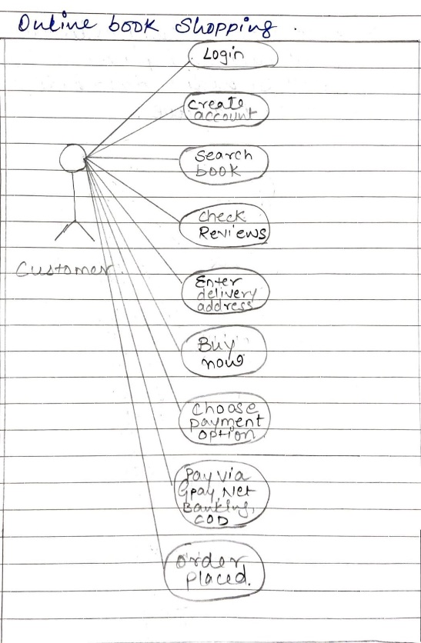

Q18. Draw Usecase on online bill payment system (paytm)

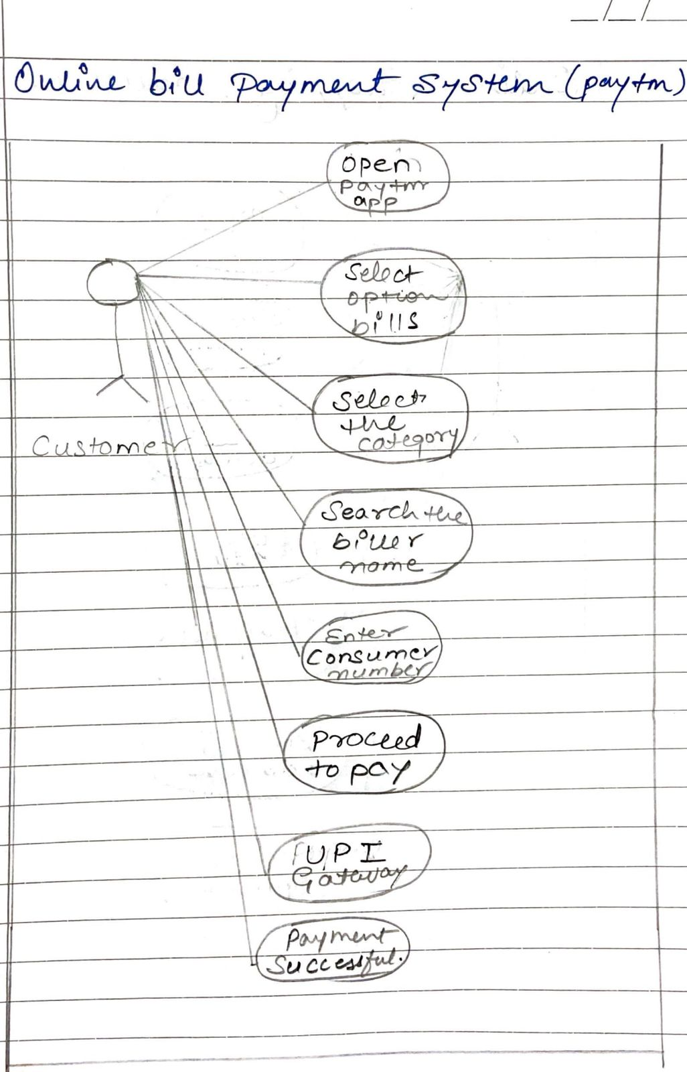

Q19. Draw usecase on Online shopping product using COD.

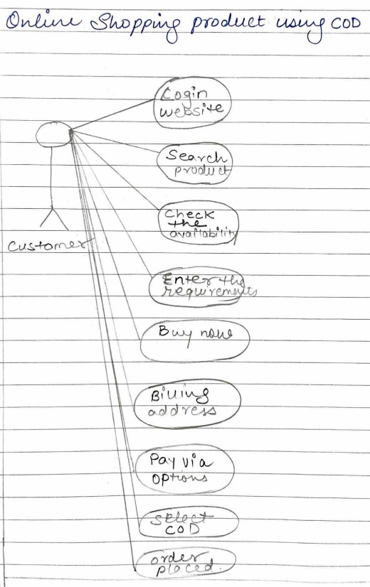

Q20. Draw usecase on Online shopping product using payment gateway.

